W-12
YEAR 10 SCIENCE (MODIFIED)
PHYSICAL SCIENCE
TEST
Name: Mark: 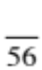

They apply relationships between force, mass and acceleration to predict changes in the motion of objects.

Part 1: Multiple Choice
MULTIPLE CHOICE ANSWERS
1
2
3
4
5
6
7
8
9
10
11
12
13
14
15
16
Write your choice for each question in the table below.

1. The change in position of an object in any direction is known as:

(a) displacement.
(b) distance.
(c) average speed.
(d) average velocity.

2. How long would a car travelling at a speed of 20 ms⁻¹ take to cover a
distance of 360 m?

(a) 13 s
(b) 26 s
(c) 18 s
(d) 34 s

3. Which of the following is a scalar (non-vector) quantity?

(a) velocity
(b) acceleration
(c) energy
(d) force

4. Which line on the following graph represents a constant speed?

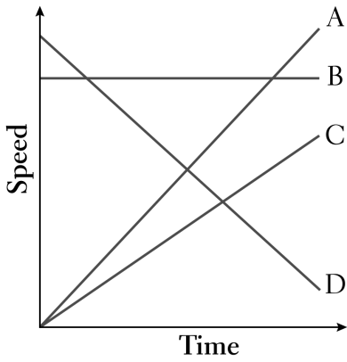
(a) A
(b) B
(c) C
(d) D

5. The rate of change of speed of an object is known as:

(a) average speed.
(b) average velocity.
(c) change in velocity.
(d) acceleration.

6. An object starts from rest and accelerates at 5.0 ms⁻². After 4.0 seconds, its speed will be:

(a) 0
(b) 10 ms⁻¹.
(c) 20 ms⁻¹.
(d) 30 ms⁻¹.

7. The tendency of an object to resist changes in its motion is called:

(a) inertia.
(b) weight.
(c) friction.
(d) work.

8. Newton’s law, known as the law of inertia, is:

(a) his first law.
(b) his second law.
(c) his third law.
(d) none of the above.

9. Belinda walks a total distance of 1200 metres to school each morning. If this trip takes her
800 seconds, her average speed would be:

(a) 1.5 ms⁻¹.
(b) 0.67 ms⁻¹.
(c) 0 ms⁻¹.
(d) 960,000 ms⁻¹.

10. An object is acted upon by a force of 50 N pushing it forwards and a total frictional force of 40 N
acting in the opposite direction. The nett force will be:

(a) 10 N backwards.
(b) 10 N forwards.
(c) 90 N backwards.
(d) 90 N forwards.

11. The size of the acceleration acting on an object of mass 10 kg that has a net force of 3.0 N acting on it
will be:

(a) 13 ms⁻².
(b) 3.33 ms⁻².
(c) 0.3 ms⁻².
(d) 30 ms⁻².

12. A vector has:

(a) direction only.
(b) magnitude (size) only.
(c) both direction and magnitude (size).
(d) neither magnitude (size) nor direction.

13. The force of gravity acting on an object is called:

(a) inertia.
(b) weight.
(c) friction.
(d) work.

14 The weight force acting on a 20 kg mass on the Earth would be:

(a) 19.8 N
(b) 198 N
(c) 1.98 N
(d) 0 N.

15. In the diagram below the arrows show the size and direction of two force arrows acting on the bike.

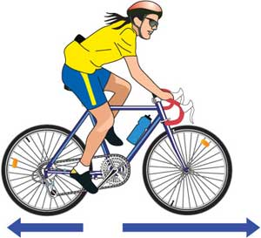

Which of the following describes the effect of the pair of forces on the bike?

(a) The bike will accelerate forward.
(b) The bike will change its direction of motion.
(c) The bike will remain stationary.
(d) The bike will decelerate.

16. The sample of ticker tape below shows:

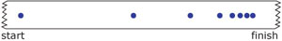

(a) a uniformly accelerating vehicle.
(b) a vehicle travelling at a constant velocity.
(c) a stationary vehicle.
(d) a uniformly decelerating vehicle.

Part 2: Short Answer

Decide whether each of the following statements is true (T) or false (F).

(a) Average speed is calculated by distance covered multiplied by the
time taken.

(b) 40.0 km/h = 144 m/s

(c) When a car accelerates quickly, you move forward in your seat.

(d) A negative acceleration occurs when a car goes backwards.

(e) A ticker timer putting 50 dots per second on the tape means that each
dot is 0.02 seconds apart.

(f) The graph below shows constant speed.
distance
time

(6)

2. Some students investigated the acceleration of a dynamics trolley down an incline plane using a ticker
timer to record the motion. The timer puts 50 dots per second (1 dot spacing = 0.02 s) onto the tape,
and the tape is shown below.

. . . . . . . . . . . . . . . . . .

Three groups of 5 dot-spacings are indicated on the diagram.

(a) Calculate the velocity for each section of the tape. Record your values for your measurements
and velocities in the table below. (Note - the time has been put in for you.).

Distance (m) | Time (s) | Velocity (ms⁻¹)
0.0 | 0.0 | 0.0
 | 0.1
 | 0.1
 | 0.1

(6)

(b) Graph the velocities versus time on the grid below.

(4)

3. The motion of a car is shown in the graph below.

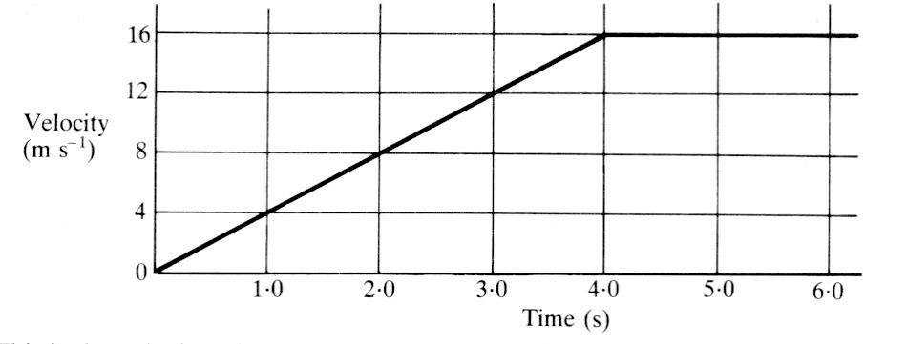

Using the area under the graph, calculate how far the car has gone in 6.0 s. Show all of your working.

(3)

4. A swimmer covers the 100 m in a race in 49.2 s. Calculate the average speed of the competitor. (Set your working out clearly.)

(3)

5. A dragster accelerates from rest at 14.5 ms⁻² for 6.90 s during a race. What is the velocity of the vehicle after this time? (Set your working out clearly.)

(3)

6. On Myth Busters, Jamie and Adam fired a 6.00 kg "shot" from an air cannon. The average force
exerted on the "shot" was 1230 N. Calculate the acceleration of the "shot".
(Set your working out clearly.)

(3)
7. An object has a mass of 25 kg.

(a) What is its weight on Earth? Show your calculation.

(2)
(b) Would the object weigh more or less on the Moon? Explain your answer.

(2)
(c) What is its mass on the Moon?

(1)

8. In moving around Learning Centre 1, a Year 7 student was observed to make the following
movements.

(i) Moved 10.0 m due south to talk with another student (time taken = 5.0 s).
(ii) Then moved 20.0 m due east to her locker to get some books (time taken = 15.0 s).

(a) Draw a vector diagram to show the motion. Draw in the resultant vector (use a different
colour). (Use a scale of 1.0 cm = 5.0 m).

(3)
(b) What is the total distance covered by the student?

(1)

(c) Determine by measurement with a ruler and protractor the displacement of the student.

(3)

